Software Requirement Specifications



Jonathan MacKenzie

Bradley Baker

Christopher Fevrier

Mark Podrouzek

Table of Contents

Dictionary & Acronyms 3

Process Constraint 3

Design Constraint 4

Functional Requirements 5

Non-Functional / Quality 9

Figure References 10

# Dictionary & Acronyms

|  |  |
| --- | --- |
| Term | Definition |
| User | A person who interacts with the application. |
| Server Administrator | A person who has elevated access to the server in question. |
| Server | A computer that manages and stores information required for the application. |
| The Application | The application refers to Roots. |
| Northwood | Northwood Long Term care facility; Halifax, Nova Scotia, Canada |
| CPU | Central Processing Unit |
| RAM | Random Access Memory |
| GPU | Graphical Processing Unit |
| OS | Operating System |
| Secondary Storage | Long Term Storage (ie. Hard Disk Drive, or Solid State Drive). |
| Ubuntu | An OS which utilizes the Linux Kernel. |
| Windows XP | A consumer grade OS developed by Microsoft released 2001. |
| Mongo DB | An application which creates and manages databases. |
| Database | A storage solution for data on a server. |
| Characters | A unique symbol (ie letter, number, or syntactic symbol) |
| MB, GB, TB | Megabytes, Gigabytes, and Terabytes respectively. Measures of data size. |
| Purging | The deletion of large quantities of data. |
| User Credentials | The Users unique UserName and password. |
| UserName | A unique string which is used to identify a specific User. |
| Password | A unique string of characters, which is known only to the User. |
| Web Browser | An application which is allows the user to access the World Wide Web. |
| Device | A personal computing device. |
| Intranet | The internal network supplied by Northwood. |
| The Development Team | The Roots development team. |
| REF X | Refer to the constraint X. |

# Process Constraint

1. Prototyping Developing Architecture

The team is utilizing the prototyping architecture for the development of the application. This process allows the potential Users to interact and give feedback on the application.

1. Development Team Time Constraints

The development team consists of full- time students, thus time is limited to each member when compared to that of other software developing firm. In addition the application is a required part of the course CSCI 3421 at Saint Mary’s University, which terminates prior to January 2018, after which all progress on the application by the development team will seize.

# Design Constraint

1. Application Compatibility

2.1.1: The application is to be designed to run using a web browser.

2.1.2: Devices with web browsers, Google Chrome, Microsoft Edge, Apple Safari, and Internet Explorer must be able to access the application.

1. Device Availability

2.2.1: The application must be able to be to operate on hardware meeting or exceeding CPU: Single Core 2.4 GHZ, RAM: 512 MB, GPU: Nvidia GeForce 5xxx, OS: Windows XP, Secondary Storage: 4GB free space.

2.2.2: For a device to run the application it must have access to a Web Browser.

2.2.3: For a device to access the application it must have a NorthWood intranet connection.

1. Server Architecture & Requirements

2.3.1: The server must be running the Ubuntu 16.0 or newer Operating System

2.3.2: The server must have Mongo DB installed.

2.3.3: The Server must meet the following hardware specifications: CPU: 4 Cores, RAM: 16 GB, Secondary Storage: 10 TB

1. Purging of Information

2.4.1: In the incident of secondary storage becoming fully utilized, the server administrator must purge posts database.

Suggested: Purge all posts which have been published over two years ago, as date of purging

2.4.2: The server administrator is to be responsible of deleting user accounts if required.

2.5: Availability of Network

2.5.1: The application is only to be accessible on a Northwood network.

2.5.2: The application is only to be available to residence and staff of Northwood.

# Functional Requirements

1. Account Creation

3.1.1: The account creation process is started with the click of the “Sign In” button located in the top left of the screen.

3.1.2: The account creation process required a Username of between 1 and 100 characters

3.1.3: The account creation process requires a password of between 0 and 100 characters.

3.1.4: The User, or assistant of the User, must enter the Users Name, a unique UserName (REF 3.1.2), a password (REF 3.1.3), and the reputation of the said password for confirmation.

3.1.5: If the entered reputation of the password does not match that of the entered password. The user is prompted accordingly and is required to renter the password and the confirmation.

3.1.6: After the User submits the Information, the Server then confirms that the UserName is not being utilized by another User. If so the User is prompted to choose a new UserName, and the process is repeated.

3.1.7: Once the account is accepted and created. The User can sign in to the application (REF 3.2).

1. Sign-In / Sign Out

3.2.1: The application must have the ability for a User to log in given a User account is not current Signed in.

3.2.2: A prompt for the User to Log in using their created credentials (REF 3.1) must be presented to the User upon clicking the log in button (REF FIG 1).

3.2.3: Once entering the Users credentials the account should log in to upon pressing the log in button within the prompted window (REF FIG 3).

3.2.4: The application must allow a User to log out of a personal account that is currently signed in.

3.2.5: A Prompt for the User to Log Out of the currently logged in account must be presented to the User upon clicking the log out button within the top right.

3.2.6 A confirmation prompt must be given to the User to ensure a mis-click does not cause a log out. Once selecting the confirmation the user will be logged out of the account. If the Cancel Button is clicked the User will return to the same state as when the Log Out button was initially clicked.

1. Profile Personalization

3.3.1: Upon account creation (REF 3.1) all Users must have access to observe a personal page of any specified User.

3.3.2: Components of this page must only be customizable by said User while logged into the specific account (REF 3.2).

3.3.3: The User must be able to customize profile picture (REF 3.4) and a personal description section (REF 3.5).

3.3.4: The User’s Personal profile must display the Users most recent posts and Profile Pictures

1. Personal Description

3.4.1: Each Users profile must contain a text entry intended for Users to write a personal statement.

3.4.2: Only the user must be able to edit this text description (REF 3.3).

3.4.3: To begin editing this description, the user must press the icon found within the top right of the text description.

3.4.4: The description must contain less than 250 characters.

3.4.5: If the Users attempts to save a description (REF 3.4.6) with more than the maximum character count of the text description (REF 3.4.4) the User will be prompted with an error window stating the description is over the designated character size.

3.4.6: The User can save or discard the edits to the description by pressing the buttons found underneath the box, save and discard accordingly.

1. Deleting Personal Posts

3.5.1: The User must be able to delete posts from the application after they have been submitted.

3.5.2: The deleting of posts can only be done from the account in which the post was published to the application.

3.5.3: The deletion can be done from the Users personal page (REF 3.3).

3.5.4: To delete a post the User must click the trash can icon located the right of the post.

3.5.5: Whenever a User attempts to delete a post a confirmation window will prompt the user to ensure posts are not deleted unintentionally.

1. Security

3.6.1: User credentials are to be stored within on a Mongo DB database on a Northwood server in plaintext form.

3.6.2: User credential security is trusted under based upon the security of the Northwood Server.

3.6.3: Server administrators are able to see in plain text User Credentials and names of Users in plain text within the Mongo DB database (REF 3.10.1) on the Northwood server.

3.6.4: The server administrator must be able to change a User’s password from the Northwood server.

1. Global News Feed

3.7.1: There must be one Centralized news feed in which any User who is signed in (REF 3.2) can publish posts to.

3.7.2: The News Feed must be shown on the home page of the application (REF FIG 1)

3.7.3: The News Feed must be able to be seen by all Users regardless of log in status or possession of an account (REF 3.1).

3.7.4: Each post published to the news feed must have a maximum of 200 characters.

3.7.5: To post to the news feed the User must be logged into an account.

3.7.6: The User may write and publish a post the news feed by typing within the box found above the news feed and then pressing the submit button.

3.7.7: Once a post is submitted for publishing it is checked if the user is logged in and that the post does not exceed the maximum character count. If either are met an error prompt is displayed for the user accordingly.

1. Personal Messaging System

3.8.1: Users must be able to send an instant message to one other user.

3.8.2: To button found within the right panel (REF FIG 1) will allow the User to navigate to the personal messaging system.

3.8.3: Each messages must have a maximum of 1000 characters per message.

3.8.4: Conversations within the personal messaging page must be sorted by most recent.

3.8.5: The personal messaging page must only be accessed from a logged in account (REF 3.2).

3.8.6: Only the two Users involved within the conversation and the administrator should have access or have the means to access pervious and current conversations.

1. Customizable Views (Font Size & Colours)

3.9.1: The User must be able to adjust the font size to a desired size.

3.9.2: The User can adjust the font size from the options button found within the right side panel.

3.9.3: To adjust the font size the User must use a sliding bar. The minimum font size is 12 point, the maximum is 40 point.

3.9.4: A colour blind mode must be made to adjust for the most common forms of colorblindness.

# 

# Non-Functional / Quality

1. Message Time

4.1.1: The time must between the publication of a message and the response of the server must be under 30 seconds within ideal conditions.

4.1.2: Users should all receive a new post to the global feed within 5 seconds of each other, under ideal circumstances.

1. User agreement

4.2.1 The User must agree that any spread or infiltration of account security is not the responsibility of the development team.

4.2.2: The User must agree to allow all Users to access to view their User profile

4.2.3: The User must be agree that their rights to the application maybe revoked at the discretion of the server administrator.

4.2.4: The User must agree that all posts, once published, are the property of the Server administrator.

4.2.5: The User must understand that posts which the server administrator deems unsuitable will be removed from the application.

4.3 User Training

4.3.1: A tutorial detailing basic User functionality of the application is to be released with the application.

4.3.2: The basic application tutorial must detail; sign up (REF 3.1), log in (REF 3.2), creating and publishing a post (REF 3.7), and profile customization (REF

# Figure References

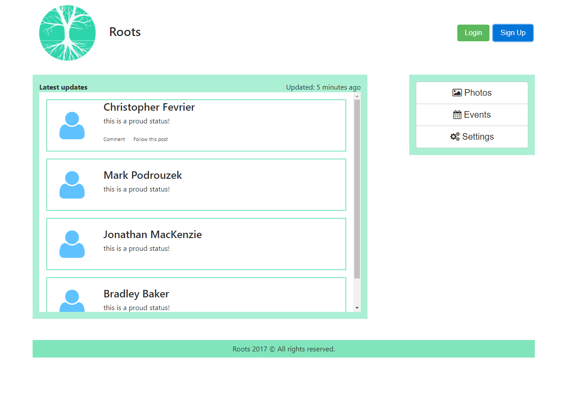FIG 1

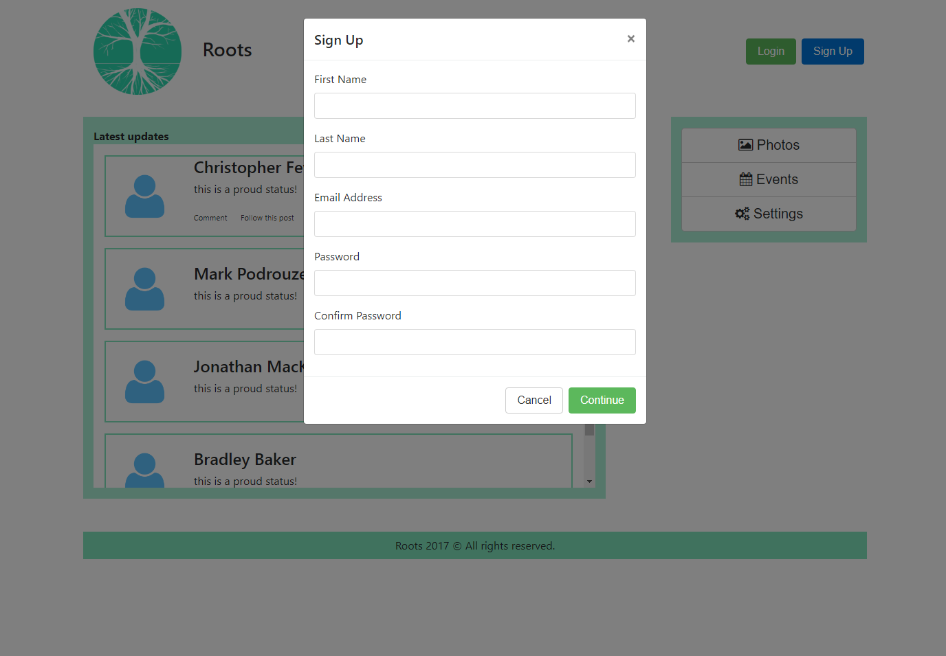FIG 2

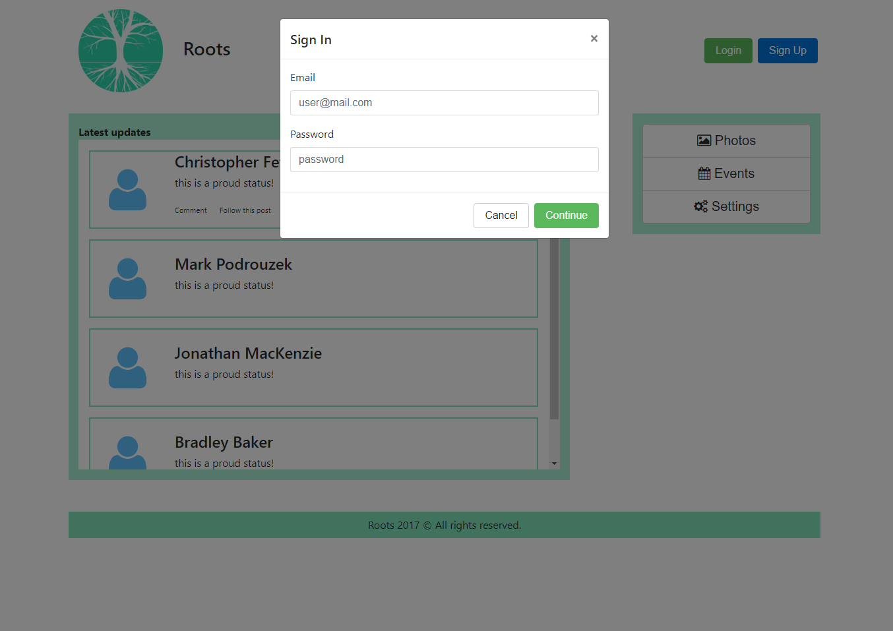FIG 3